CCTA Operation Manual

# **Equipment Needed**

|  |  |
| --- | --- |
| **Item** | **Purpose** |
| CCTA Physical System |  |
| Laptop with MATLAB r2023a or later installed | To operate the CCTA |
| CCTA MATLAB App | To control the CCTA |
| Syringe with male luer lock fitting | Debubble pressure transducers for pressure testing |

# **System Operational Procedure**

1. **Set up the flow system**
   1. Connect the pump inlet and outlet with 3/8” tubing
   2. Position system components (i.e. tubing, connectors, valves, heart model, flow meter(s), and pressure transducer(s)) at the desired test point locations within the system
   3. Fill reservoir with water (e.g. use a separate bucket and fill it up at a sink)
2. **Set up the control box**
   1. Connect the flow meter connectors to the ports on the control box:

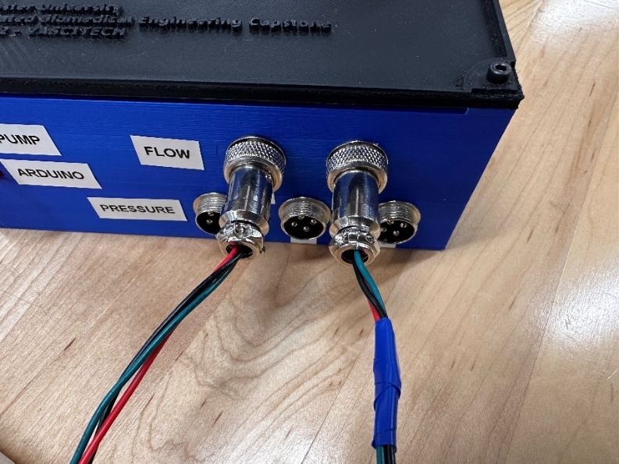

* 1. Connect the pressure meter connectors to the ports on the control box:

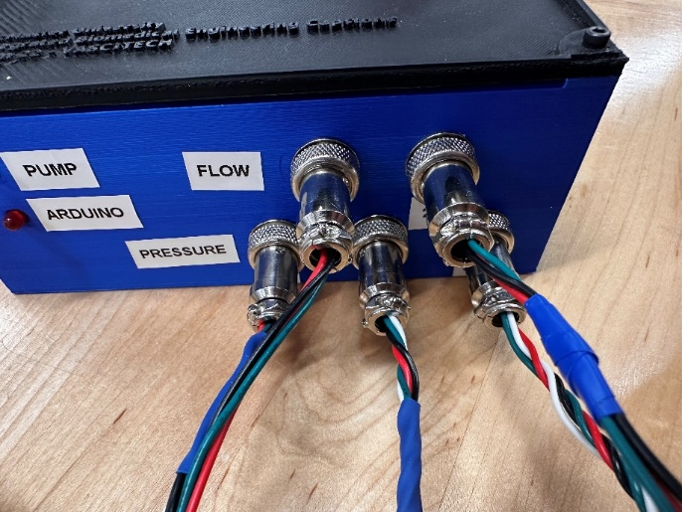

* 1. Connect banana plugs between the power supply and the control box:

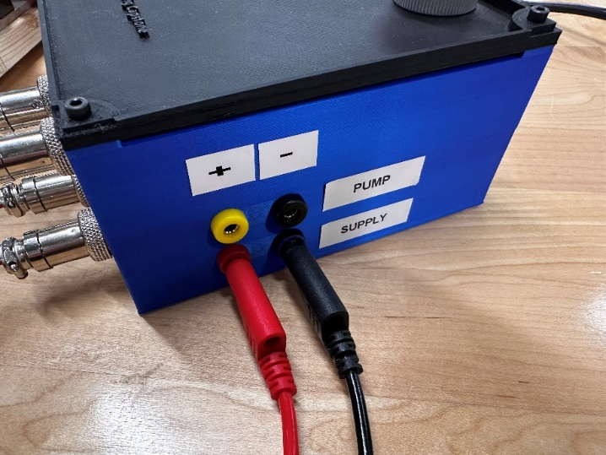

* 1. Connect banana plugs between the control box and the pump:

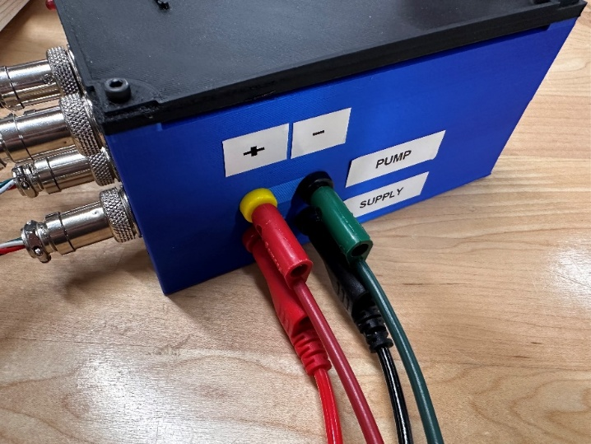

* 1. Connect the user’s computer to the USB port on the control box and ensure the red LED on the control box lights to indicate successful connection:

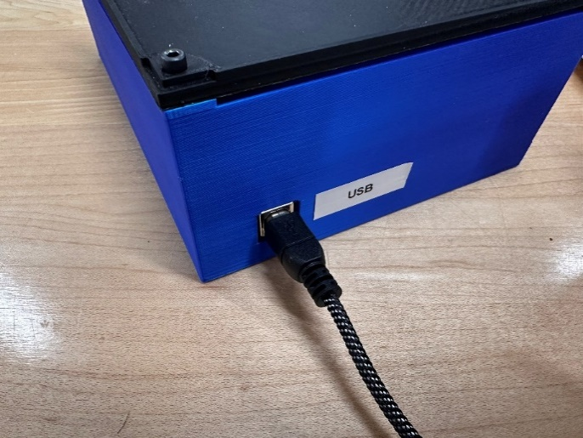

1. **Start the system**
   1. Turn on the power supply, set to 12 V and a 3.3 A
   2. Run the GUI in MATLAB (i.e. run the CCTA.mlapp file using MATLAB) and connect to the appropriate COM port (it should say “Arduino Uno” in the dropdown)
2. **Test basic functionality of the GUI**
   1. Confirm that baseline flow and pressure are being reported in the GUI (in the textboxes as well as the graphs)
      1. When the pump is off, flow values should be 0 and pressure values should be low (around 8-10 mmHg, corresponding to the static head offset in the system)
   2. After confirming basic GUI functionality and enabling pump power, you can select the Control Mode from the dropdown menu in the GUI. The system provides three modes:
      1. Manual (default)
      2. Auto
      3. Pulsatile

Use the dropdown menu (see below) to switch between modes as needed for your experiment:

* 1. **Manual Mode (Default)**

* + - Enable pump power by toggling the slider to On.
    - Ensure the system is operating in Manual Mode (check the Control Mode dropdown).
    - Set an initial Pump Power (%) value (recommended to start at 50%) to confirm proper system function.
    - Confirm the blue LED on the control box lights up, indicating the pump is receiving power.
    - Adjust the Pump Power (%) slider or input box manually to increase or decrease the pump speed.
    - Verify that changes in pump power result in appropriate changes in flow rate and pressure on the GUI.
    - Confirm that other GUI elements behave as expected (hover over buttons for descriptions).
  1. **Auto Mode**

In Auto Mode, the system automatically adjusts pump power to maintain a specified target flow or pressure using PID control.  
Steps to operate in Auto Mode:

* DO NOT select Auto Mode from the Control Mode dropdown (this will not work).
* Instead, enter your desired Target value in the box corresponding to a specific flow or pressure sensor.
* Press Enter to confirm. The Target box just chosen will highlight green, and the pump power slider and spinner will be slightly greyed out, indicating the system has accepted the target and is actively adjusting pump power.  
    
  A screenshot of a computer

  AI-generated content may be incorrect.
* Observe the Pump Power (%) value changing automatically as the system adjusts to reach the target.
* Wait for the system to stabilize at the setpoint before beginning any measurements or catheter testing.
  1. **Pulsatile Mode**

In Pulsatile Mode, the pump output follows a simple sinusoidal waveform designed to mimic physiological flow conditions, such as a heartbeat. This mode allows you to adjust two key parameters:

* Pump Power (%): Controls the amplitude of the pulses (i.e., the peak pump power during each pulse). Higher values increase the pulse strength.
* Pulse BPM (Beats Per Minute): Sets the frequency of the pulsatile waveform, determining how many pulses occur per minute.

Steps to operate in Pulsatile Mode:

* Select Pulsatile Mode from the Control Mode dropdown.
* Set the Pump Power (%) to determine the amplitude of each pulse (default 100%).
* Set the Pulse BPM value to define the pulse frequency (default 40 BPM).
* Observe the flow and pressure waveforms reflecting the pulsatile output in real-time on the GUI graphs.
* Adjust Pump Power (%) and Pulse BPM as needed to simulate desired physiological conditions.

1. **Catheter testing (Flow Simulation)**
   1. Open the needle valve to the silver line (fully open).

Silver Line

* 1. Enter a setpoint value for one of the flow sensors to begin PID control, depending on the desired parameter to be controlled. Press enter to confirm your target value, and the appropriate target box should highlight green:

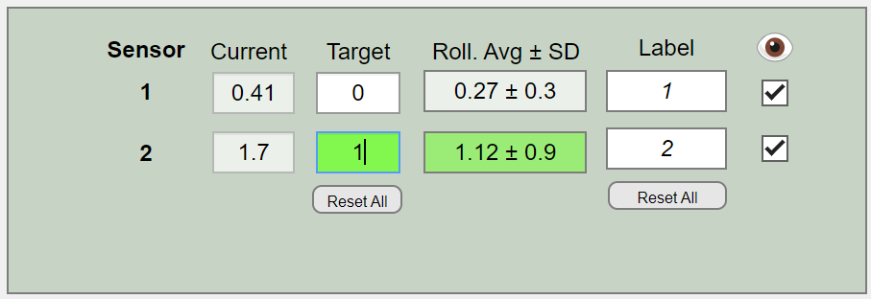

* 1. Verify that the “Pump Power (%)” is changing appropriately based on the error between the current value and the target value (i.e. is the pump increasing/decreasing power appropriately to reach its target)
  2. Wait for the system to stabilize to the setpoint
  3. Begin catheter testing

1. **Catheter testing (Pressure Simulation)**
   1. Open the needle valve to the silver line (fully open).

Silver Line

* 1. Set the Pump Power to 50%.
  2. Debubble each pressure sensor using a syringe.
     1. Push bubbles by squeezing the flexible tubing.
  3. Calibrate the pressure sensors to remove the Static Head Offset (SHO) by clicking “Calibrate” on the MATLAB App.

* + 1. Follow all steps listed on the GUI
  1. Adjust the needle valve slowly until the pressure gauge reads your target value:
     1. While you turn the needle valve, watch the regulator’s analog gauge—any movement of its pointer means the regulator is active and smoothing out pressure spikes.
     2. Make sure the gauge never exceeds 30 PSI.